Phase 2 Uplift Plug-In Problems

1. System Setup : To enforce auto post uplift to control account means that their system must be setup as live stock method. There is nothing in the spec to confirm this fact.
NF: This is one for KH / the customer to address.

2. Filtering Tab : Include uplifted freight on line types 0 to 4. What does this mean? If I untick this box, then should I even have used the Freight option?
NF: If you untick this box then it will only try and apply uplift on line types that are not line type 0-4.

3. Filtering Tab : Include Non stock code lines? What does this mean? Is this non stock or description only stock? If non stock then where would we record the cost?
When incorporated into tests this option returned the following error message
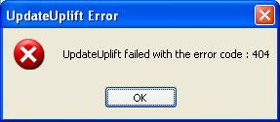
NF: This Error 404 means that it is trying to lookup the Location which is stored against the transaction line. Since on Non-Stock lines you can put what you like in the location field, and it is not validated then it is not surprising that it cannot find the Location Record.
When I tried this on my system I got an error 204, which is cannot find Stock Record – again not too surprising, as there is no stock code. The problem here is that the Function I am using : UpdateUplift in the COM toolkit cannot handle Non-Stock Items.
There are 2 ways to resolve this :
1. Change the Plug-in so that it can never add uplift onto non-stock items. You could argue that it is meaningless to put an uplift value on a Non-Stock Line, as the uplift value is only used for stock valuation purposes in Exchequer, and it isn’t a stock item.
2. Change the COM toolkit so that it can update the uplift for Non-Stock Items. You could argue that although the value is meaningless, we need to have it there, in order for our plug-in to do its work.
I will have to leave this in the hands of Kevin, or the customer, as to which route we take for this one.

4. Uplift and FIFO
I am not convinced that this system supports partial delivery of PORs as the uplift can have an undesirable effect on the FIFO database and subsequent cost prices of items delivered with or without additional uplift.
For example
If I add a POR and for qty of 10 and partially receive 2 items. I then add uplift based on the delivery of the two items.
The effect on the FIFO database for the original order means that all 10 items appear to have attracted the uplift value calculated on the two received items. This distorts the cost value completely.
This is compounded when I receive an additional qty of 1 as the order generates the PDN for the single item and incorrectly inherits the uplift and non dated notes from the originating order.
If further quantities are received that attract their own uplift values then this will have a further effect of the uplift and costs price stored in the FIFO database..
NF: This is another one that Kevin or the customer will have to make a judgment on, although Kevin did originally tell me that they would not be doing partial deliveries.

5. Matching Info : The matching info from the NOM correctly shows the matched PIN’s but with zero value.
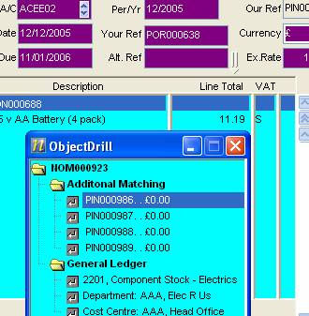
NF: I have added the value in version v5.70.005

6. Rounding on NOMs : Should I have zero value rounding lines on my NOMs ?

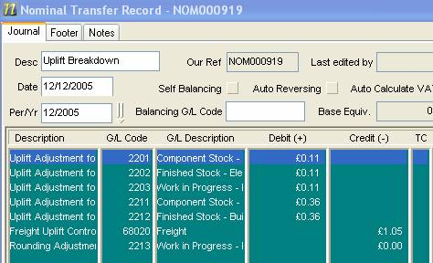

NF: I have made some mods, and I am hoping this won’t happen anymore. I couldn’t actually replicate the fault though. Hopefully this has been fixed in version v5.70.005

7. Sub-Companies : I’m now working on the testing of the sub companies.
This error appears when I click on the <freight> button.
The P2UlftPI.INI is located both in the root company folder & in the subsidiary company folder.
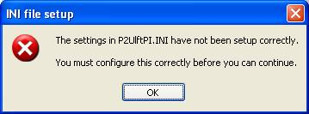
I have checked that all the G/L codes & cost centre & dept codes exist in the subsidiary company.
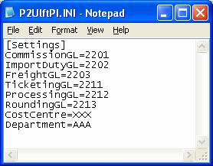
NF: This have been fixed in version v5.70.005

8. Standard costing Valuation method.
You clearly state in the Plug-in Proposal Version 1.3(NF) page 3, that this plug-in does not support Standard costing as a valuation method.
However I have been able to calculate uplift for a standard valuation stock item. I therefore wonder if a warning
message might be suitable in this instance.

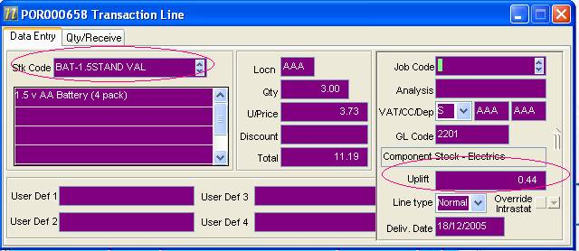

NF: Another one for Kevin.

9. BOM Problems
NF: We are still looking into these issues.

